REFORMS IN EXISTING EDUCATION POLICY VIA NEW EDUCATION POLICY:
Scrutinizing the National Education Policy 2020
Aadya Pandey
ABSTRACT

The New Education Policy 2020 (NEP 2020) brings a sea change in the entire education system of the country, including its regulation and governance, which aligns with SDG4. India is set to be the third largest economy after the United States and China by 2050. Considering the situation of the current pandemic of COVID-19, which has brought the functioning of the entire world to a halt, the nation needs to focus on challenges like dealing with climate change and increasing pollution. This calls for strong research institutions and an excellent infrastructure which further calls for a change in pedagogy. The policy aims for the holistic development of an individual. With the restructuring of the 10+2 education system to 5+3+3+4, one of the most important visions of the policy is introducing the Early Childhood Care and Education (ECCE). Over 85% of the cumulative development of the brain occurs prior to the age of 6. The ECCE would help the individual develop a healthy and critical brain. Reducing the dropout rate, another vision of the policy, would be a great step towards maintaining the gender ratio in the schools and higher education. This would not only ensure liberation of women but also that they have their financial agency.
However, the policy brings a lot of concerns with it as well. The “foundation literacy and numeracy mission” leads to scepticism due to the underqualification od Aganwadi teachers. Also, bringing everyone under the umbrella of “Socio-Economically Disadvantaged Group” further hampers equity keeping in account the rise in violence against Muslims and Dalits.
This paper highlights the merits and demerits of the policy at various fronts and discusses the transition brought by it and its effects on the hoi polloi at large. Further, it makes an attempt to put across some suggestions by the researcher in order to make the policy citizen-friendly so as to smoothen the implication.

TABLE OF CONTENTS

- Abstract 02
- Introduction 04
- Early Childhood Care and Education (ECCE) 04
- Twin Objectives: Achieving 100% Gross Enrolment Ration (GER) by 2030 and Ensuring Universal Access to Education At All Levels 05
- Vocational Education 09
  - Provisions for Vocational education in the NEP 2020 10
- Multilingualism and Mother Tongue as the Medium of Instruction 11
- Equitable and Inclusive Education 13
  - Gender Inclusion Fund 14
  - Provisions for Persons with Disablities 15
- Suggestions 16
- Conclusion 18
- References 19

INTRODUCTION

The National Education Policy, 2020 will replace the current National Policy on Education, 1986. This new policy falls in line with Atmanirbhar Bharat Programme under which a National Initiative for Proficiency in reading with Understanding and Numeracy (NIPUN Bharat) will be launched. Recommending some significant changes in the entire structure of education, inclusion of Socio-Economically Disadvantaged Groups (SEDGs), multilingualism and imparting vocational education are some of the key aspects of this policy.
With 1.3 billion population, India becomes the country with the highest number of people involved in the service sector. Due to poverty and the financial constraints it brings, education is associated with employment in India which calls for the youth to be skilled so as to be able enough to work in both the formal and the informal sectors.
This paper deals with five major aspects of the policy – Early Childhood Care and Education (ECCE); Achieving 100% Gross Enrolment Ration (GER) by 2030 and ensuring universal access to education at all levels; Introduction of vocational education; Multilingualism and mother tongue as an umbrella term and; Equitable and inclusive Education. Scrutinizing each of the five aspects, some suggestions have been put across by the researcher.

EARLY CHILDHOOD CARE AND EDUCATION (ECCE)

Over 85% of a child’s cumulative brain development occurs prior to the age of 6, indicating the critical importance of appropriate care and stimulation of the brain in the early years in order to ensure healthy brain development and growth. The policy emphasises on the mission that by the end of class 3, every child should have acquired foundational literacy and numeracy. According to Annual Status of Education Report (2018), even at the age of three, seven out of ten children are enrolled in Aganwadis. The private schools enroll children in KinderGarten (KG) before entering into class I. In the Government sector also, the students are required to get themselves enrolled in Aganwadis in the community or those which are physically located in the school compounds. The newest in the race are Punjab and Himachal Pradesh bringing pre-primary schools into their school structures.
For the first time, children belonging to the age group of 0-6 years are included in the formal education system which was hither to a Directive Principle of State Policy (DPSP) under Article 45 of the Constitution of India. The policy aims to achieve optimal outcomes in the domains of physical, cognitive and motor development.

TWIN OBJECTIVES: ACHEIVEING 100% GROSS ENROLLMENT RATIO BY 2030 AND ENSURING UNIVERSAL ACCESS TO EDUCATION AT ALL LEVELS
The National Education Policy 2020 aims to achieve 100% Gross Enrolment Ration in pre-school to secondary level by 2030. According to the Ministry of Human Resource Development (MHRD) school- based information, the number of enrolled children in elementary schools, primary and middle (i.e., grades 1 to 8) increased from 22.27 million in 1950-1951 to 182.0 million in 2004-05, about an eight-fold increase since 1950.Though it indicates a rapid progress in the number of children enrolled, it is unable to indicate the progress in the goal achievement, i.e., universalisation of elementary schooling.
In the Indian context, it is a fact that a massive number of children remain out of school; many of them do not even have the slightest idea of how school premises look like.
Analysis of India’s District Information System for Education data shows that:

- Grade 5—the terminal grade in the primary cycle—has the highest dropout (15.9%).
- Grade 5 dropout exceeds dropout in other primary and upper primary grades by 53% (grade 1) to 189 % (grade 6).
- Grade 6 and 7 dropout rates (5.5% and 5.8%, respectively) are lower than those of the primary grades, suggesting that students are less likely to dropout at higher grades. (Data not available for Grades 8-12).
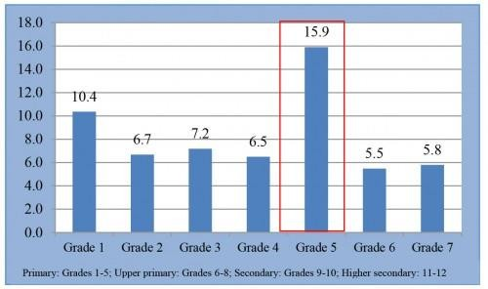

The major reasons for dropouts according to National Sample Survey Office (2010) included Financial Constraints – 21%, Child not interested in Studies – 20%, Unable to cope up or Failure in studies – 10%, Completed “desired level” of class – 10%, Parents not interested in Studies – 9%, Participating in other economic activities – 6%, To work for wage/salary – 6%, to attend other domestic chores – 5%, for helping in household enterprises – 3%. Other reasons were child marriage, school was far, unsuitable timing of educational institution, unfamiliar medium of language/instruction, to look after younger siblings, amongst other. (NSS0 2010)
Chapter 3 of the policy states - Providing regular trained teachers at each stage, special care shall be taken to ensure that no school remains deficient on infrastructure support. The credibility of Government schools shall be re-established and this will be attained by upgrading and enlarging the schools that already exist, building additional quality schools in areas where they do not exist, and providing safe and practical conveyances and/or hostels, especially for the girl children, so that all children have the opportunity to attend a quality school and learn at the appropriate level. Alternative and innovative education centres will be put in place in cooperation with civil society to ensure that children of migrant labourers, and other children who are dropping out of school due to various circumstances are brought back into mainstream education.
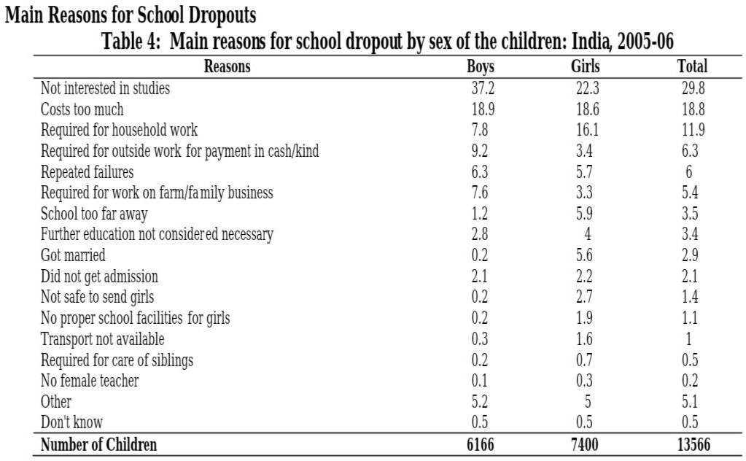

Data Source: https://www.researchgate.net/publication/303381535_ACCESSIBILITY_TO_HIGHER_EDUCATIO N_FOR_PERSONS_WITH_DISABILITIES_IN_INDIA.
“National Survey of Estimation of out-of-school children in age 6-13 in India” conducted by the Ministry of Human Resource Development pointed out that children in rural areas drop out of school earlier than those in urban areas. Majority of the drop outs in rural areas are educated up to class II while those in urban areas are educated up to class V.
In higher Education also we have lesser number of women. Women do not tend to join the Higher Education Institutes (HEIs) due to a lot of factors. Most important of them being – marriage as soon as they turn 18 years of age and financial constraints as parents prefer to educate the son.

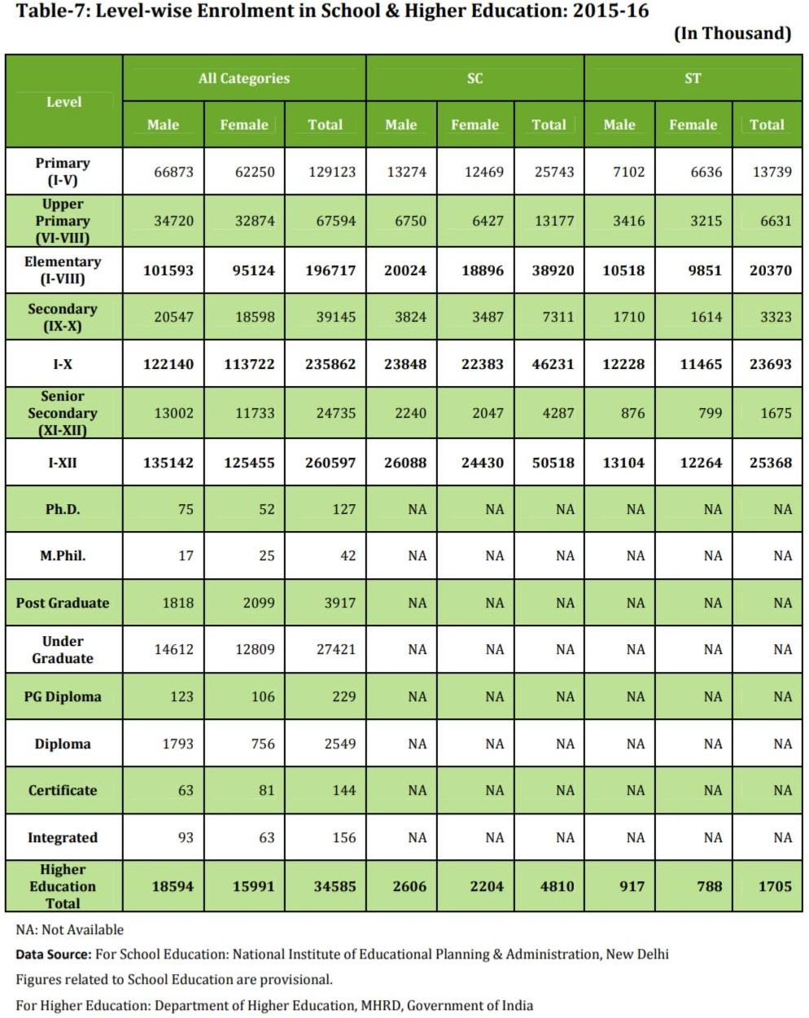

It is critical to have a mechanism to identify girls at risk of dropping out and implement mechanisms to bring those that have dropped out back into school. The new definition of a dropout, 30 days of continuous unexcused absence, is a start, but would be inadequate; more regular touch points are needed to create timely corrective measures to ensure timely regular attendance. Also, there is a dire need of infrastructure in the government schools so as to make the teaching and learning process interesting for the students. There has to be an increases in the funds by the Government at all the levels of school and higher education.

VOCATIONAL EDUCATION

The United Nations Population Fund (UNFPA) has defined ‘demographic dividend’ as the growth potential that results from shifts in a population’s age structure. A study conducted by the UNFPA noted that India has an important window of demographic dividend opportunity from about 2005-06 to 2055-56 with 62.5% of the population falling in the working age group of 15 and 59 years. It is expected that the slice of working age group will rise to 65% (approximately) by 2036.
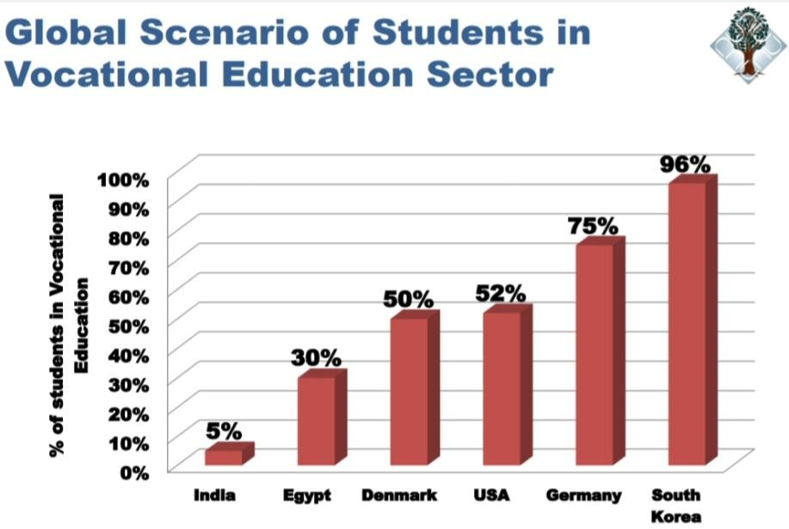
Data Source: https://www.education.gov.in/shikshakparv/docs/Sitansu_Jena.pdf.

Due to India being a service-based economy, education is India is associated with employment. People here enrol their kids to school or HEIs so that they could fetch a job and later earn money for themselves.
Students drop out from schools and get indulged in vocational activities in order to earn money and feed their family. It is only in 2007 that India had a net enrolment rate of 97% at primary level (classes 1 to 5) of general education. This implies that most children dropped out of primary school early and entered into workforce did not even have general education, let alone vocational skills.
For the first time in India, a skills framework was included in India’s Five Year Plans which stated - The NSS 61st Round results show that among persons of age 15–29 years, only about 2% are reported to have received formal vocational training and another 8% reported to have received non-formal vocational training indicating that very few young persons actually enter the world of work with any kind of formal vocational training. This proportion of trained youth is one of the lowest in the world. The corresponding figures for industrialized countries are much higher, varying between 60% and 96% of the youth in the age group of 20–24 years. One reason for this poor performance is the near exclusive reliance upon a few training courses with long duration (2 to 3 years) covering around 100 skills. In China, for example, there exist about 4000 short duration modular courses which provide skills more closely tailored to employment requirement. Even the 12th Five-Year Plan (2012–2017) estimates indicate that fewer than 5% of the Indian workforce between the age of 19-24 received formal vocational education.

PROVISIONS FOR VOCATIONAL EDUCATION IN THE NEP 2020

The National Education Policy 2020 aims to integrate vocational education in schools and higher education institutions in a phased manner. Making the education more structured, the policy recommends to conduct a proper skill gap analysis and mapping of local opportunities to assign those vocational courses which are relevant to the particular area. Further, the policy also stresses upon the National Skills Qualification Framework (NSFQ) which will help in assessing the prior learning of the students enrolled and hence, will help in the reintegration of the dropouts in the mainstream education. The policy also aims to overcome the social status hierarchy associated with vocational education by :
- Integrating vocational education into mainstream education in all educational institutions in a phased manner. This would lead to emphasizing the dignity of labour and importance of various vocations involving /Indian arts and artisanship.
- Imparting vocational education from class 6, in the form of internships and other practical apllications, so that each student has at least one vocational course.

One important facet of the policy is that it emphasises on practical experience. But at the same time it is important that the educational institutions provide the education with the motive to actually get the students engaged in practical learnings and do not provide internships and certificates for the sake of it as practical learning opportunities for students should not become indirect means to exploit them. The “dignity of labour” is directly associated with the availability of jobs that require the labour, acquired qualification as well as acknowledgment in material senses of the skills they possess. Unless the government creates jobs that acknowledges and incentivises these qualifications, these reforms suggested by NEP 2020 will be rendered ineffective. Even if students learn basic vocational skills, they may not still choose them as a viable career opportunity if they don’t have enough opportunity in the employment market. The informal economy, which is the largest in the country, needs to be involved in the process of enhancement of the NSQF.

MULTILINGUALISM AND MOTHER TONGUE AS THE MEDIUM OF INSTRUCTION
It is a well-known fact that it becomes easier to grasp information for one when the medium of communication is one’s mother tongue. The National Education Policy 2020 says, “Wherever possible, the medium of instruction until at least Grade 5, but preferably till Grade 8 and beyond, will be the home language/mother tongue/local language/regional language. Thereafter, the home/local language shall continue to be taught as a language wherever possible. This will be followed by both public and private schools. High-quality textbooks, including in science, will be made available in home languages/mother tongue. All efforts will be made early on to ensure that any gaps that exist between the language spoken by the child and the medium of teaching are bridged”.All efforts will be made in preparing high-quality bilingual textbooks and teaching-learning materials for science and mathematics, so that students are enabled to think and speak about the two subjects both in their home language/mother tongue and in English.
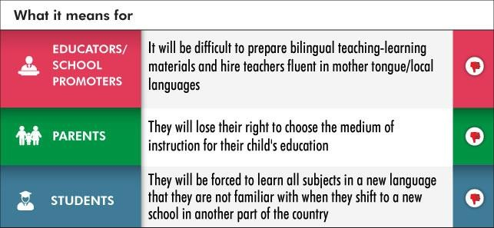
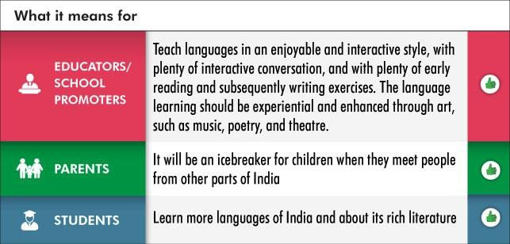

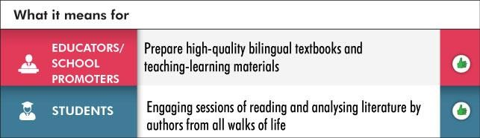

However, teaching students in their mother tongue does not seem to be a feasible option when we come to know that India is the land more than 1000 languages. According to UNESCO, 197 Indian languages are endangered. One might look at this report as a warning to preserve the languages but teaching those languages at schools would do no good. According to UNESCO, a language becomes endangered when its speakers are only from the older generation. Coming to my point, how will the government manage to hire translators and teachers for the languages which are not even spoken by them? Most importantly, many children have dialects as their mother tongues, for instance, Uttarakhand has two major dialects, Kumaoni and Garhwali, and one major language – Hindi. Will a separate school be opened particularly for the speakers of Kumaoni or Garhwali? If yes, then there will be no unity in a state itself, let alnoe the entire country. The policy does not provide any recommendation as to how will such states carry out the process smoothly.
4.29 (NEP 2020) states that the curriculum in the foundational stage will be redesigned and be rooted in Indian and local context and ethos in terms of culture, traditions, heritage, customs, language, philosophy, geography, ancient and contemporary knowledge, societal and scientific needs, indigenous and traditional ways of learning etc. – in order to ensure that education is maximally relatable, relevant, interesting, and effective for our students. This must be a serious concern for the nation as a whole. Following such an educational structure will lead to differences among the students of different states as the syllabus will be based on the local context of that particular state which will lead to a difference at the grassroot level of education. This might be a threat to Unity in Diversity. Hence, there is a dire need of a lingua-franca as to make the students across the country united at the same level.

EQUITABLE AND INCLUSIVE EDUCATION

Certain sections of the society do not have access to education due to various reasons. They become excluded which leads to wastage of the potential of the youth of the nation. The NEP 2020 aims to address this growing inequality in the current education system.

GENDER INCLUSION FUND (GIF)

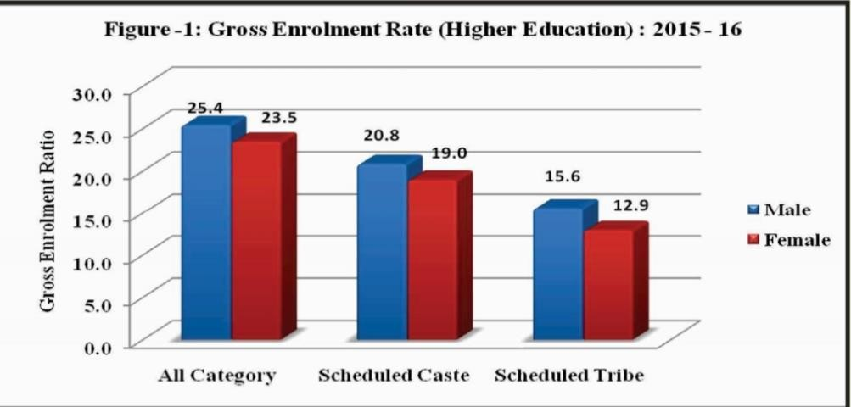
The introduction of Gender Inclusion Fund (GIF) is a decent start to work for women and the transgender community. Recognising their special needs, the NEP 2020 recommends a series of policies and schemes such as targeted scholarships, conditional cash transfers to incentivize parents to send their children to school, providing bicycles for transport that have worked in the past to increase enrolment, to create more representation. Women end up dropping out of schools due to the construct of patriarchy which does not believe in letting the women have a financial agency over themselves. Social evils like child marriage and sexual abuse restrict a lot of women in India from having access to education.
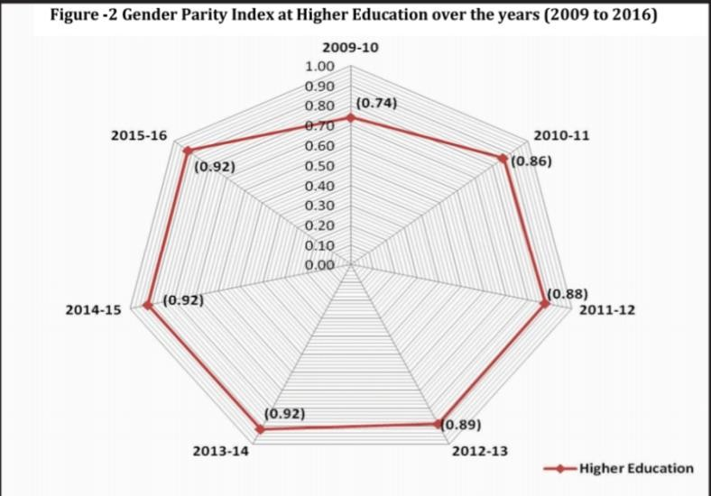
The above two figures are from the 2018 report “Educational Statistics at a Glance” by MHRD.Table 2 shows the increasing female participation at all levels. However, the equation does not hold true when the index is calculated on school management level. Parents seem to have a preference to send their sons to private schools. This directs towards the extreme inequality which still prevails in the Indian society.
Transgenders on the other hand are yet not accepted by a large portion of the society. They face rejection at the hand of the employers. Also, due to the existing social stigma, their parents either abandon them or even if they accept, they don’t believe in investing in a transgender child.

PROVISIONS FOR PERSONS WITH DISABILITIES

According to TRRAIN HSBC Disability Employment Report 2019, 46% of persons with disabilities are uneducated in India. The report also stated the reasons behind the lack of poor education of PwD population. The major reasons were lack of right schools, unavailability of special instructors, and most importantly, the reluctancy of parents to invest in the education of their child with a disability. Children with disability are five times more likely to stay out of school than those belonging to Scheduled Castes or Scheduled Tribes.The NEP 2020 claims to incorporate the Indian Sign Language (ISL) in the teaching curriculum. Teachers will be given formal training and special instructors will be hired to teach.
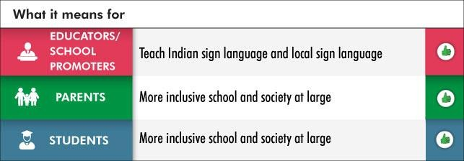

The NEP also acknowledges the crucial role played by teachers in the identification of certain disabilities. However, it only includes specific learning disabilities and completely neglects other developmental and intellectual disabilities. The policy discourse on inclusive education in India has by and large, confused integration and inclusion, focusing on solutions to allow CWDs to integrate into the system rather than questioning and evaluation of existing practices, based on the recognition of disability as a result of structural and attitudinal limitations. This is apparent from the pervasive neglect of quality of education and learning outcomes for CWDs and a persistent insistence on models like home-based education. Inclusive education has to be conceptualised as a system wide practice, rather than being viewed as a specialised service for CWDs, an approach that calls for greater budgetary allocation and inter-ministerial convergence. Moreover, availability of appropriate data is indispensable for targeted policy interventions which necessitates efforts to counter under-reporting of disability by using appropriate data collection systems such as the Washington Group/ UNICEF Module on child functioning. It is also crucial to design qualitative and adaptable assessment frameworks to evaluate learning outcomes for CWDs and address their exclusion from the teaching-learning process. It has been established that inclusive education practices are beneficial for children with and without disabilities and enhance the overall quality of education imparted. Therefore, an evaluation of existing practices, together with increased stake-holder convergence should be employed to honour the commitment towards inclusive and quality education for all.
The NEP 2020 has recognised all the minorities under the single umbrella term: Socio-Economically Disadvantaged Groups. However, it does not state the reason behind certain communities being minority to others. A Dalit woman does not have the same status as that of an upper caste woman. The former is doubly marginalised due to her caste, same goes with the woman who is a Muslim. The severity of the persisting inequalities has been brushed off by the nomenclature in question. The existence of patriarchy, the primary reason for the exclusion of the minority groups, has no mention in the policy. The phrase seems to be ambiguous and is highly probable of causing more inequalities amongst the various sections of the society.

SUGGESTIONS
Need for lingua-franca: In a diverse country like India, it is important to instil the felling of unity amongst the citizens. The policy stresses over teaching the students in their mother tongue but there is no recommendation regarding the languages which have a very small number of speakers. In order to progress, a nation needs to have a uniform system of education. This is the primary reason behind shifting the subject of “education” from State List to Concurrent List through the 42nd Amendment Act of 1976.
- Addressing the reasons behind backwardness: Mere nomenclature of the minority groups and bringing them under the same umbrella, Socio-Economically Disadvantaged Groups or SEDGs – will not acknowledge what the real issue is. The policy does not address the reasons behind the persistence of such inequalities. Muslim and Dalit minorities will find it difficult to fare within the system. Hence, the Government should reconsider its decision of clubbing all the minority groups under one umbrella.
- School/College infrastructure: In 8.7, the policy states that the government and the private institutions will be assessed on the same yardstick. It seems to be difficult in the current scenario when the government institutions are far behind the private ones in terms of infrastructure and funding. The parameters to judge, at least for now, should be different for the government run institutions than those for the private institutions so that the assessment could be more rational.
- Recruitment of qualified and well-equipped professionals: Multilingualism calls for the recruitment of well-qualified professionals to educate the students in their mother tongue. Mother tongue is an umbrella term for the languages as well as the dialects spoken in a particular area. A lot of people have a dialect as their mother tongue. The Government needs to ensure to recruit such teachers who are qualified enough to teach in the dialects which are spoken by a small number of people. Not only teachers but translators are also required who can covert the textbooks in such languages. Implementation of the policy in this domain is very crucial since the medium of instruction forms the base of education. For example, (1) Languages, (2) Basic Sciences, (3) Social Sciences, (4) Engineering, (5) Education, (6) Medical Sciences, (7) Dental Sciences, (8) Para-medical sciences, (9) Business Management & Commerce, (10) Computer Science, (11) Agriculture & Veterinary Science, (12) Law & Legal Studies, (13) Indian Medicines, (14) Indology, etc.
Proper definition of a multidisciplinary university: A multidisciplinary university should have a minimum of five disciplines (and not five courses) belonging to different faculty areas. The objective behind studying in a multidisciplinary campus to provide multidisciplinary choice and experience of campus comes only when the number of subject disciplines are five.
- Focus on health and safety to prevent physical disabilities and other health issues: Vocational Education will require the students to deal with a lot who tools and instruments which could cause injury. The infrastructure of the educational institutions should be as such that the health and safety of the students is well take care of.
- Need to shift from “universal access to education” to universal “entitlement” to education: According to Right to Education Act, education is the fundamental right of the child between the ages of 6 to 14. “Access” implies the probability of a certain section of the society is denied education or it is not able to exercise its fundamental right. Every child between the ages of 6 to 14 is entitled to education. The policy makers need to be more careful of the words they choose.
- Clarity on Right to Education of Choice: The policy talks about homeshcooling only with respect to the persons with disability. A very small number of people in India prefer to home school their children, right to education if choice is in question as no recommendation has been made with regard to the persons without disabilities opting for homeschooling.

CONCLUSION
Considering the lack of infrastructure and current facilities in the Government run educational institutions, the claims made by the policy seem to be in question. The concept of multilingualism poses a lot of questions as it will require the government to invest heavily in the resources. Translating the textbooks and recruitment of well-qualified teachers will form the very base of this policy. The reasons behind the high dropout rates are somewhere deeply rooted in the society. Achieving 100% GER calls for active functioning of other ministries as well. The issues of caste, religion and women safety cannot be brushed away with.
The policy does aim to enhance the mental development and cognitive skills of the students. However, some claims appear to be ambiguous as of now. The execution and implementation will play the pivotal role in making the policy a success.

REFERENCES

JOURNALS/ARTICLES

- M Venkataramayana, Schooling Deprevation in India, 44 ECONOMIC AND POLITICAL WEEKLY 12, 12 (2009).
- P. S. Aithal & Shubhrajyotsana Aithal, Analysis of the Indian National Education Policy 2020 towards Achieving its Objectives, INTERNATIONAL JOURNAL OF MANAGEMENT, TECHNOLOGY AND SOCIAL SCIENCES, https://www.researchgate.net/publication/343769198_Analysis_of_the_Indian_National_Educatio n_Policy_2020_towards_Achieving_its_Objectives.

REPORTS

- National Education Policy 2020, MINISTRY OF HUMAN RESOURCE DEVELOPMENT, https://www.education.gov.in/sites/upload_files/mhrd/files/NEP_Final_English_0.pdf.
- 11th Five Year Plan, PLANNING COMMISSION OF INDIA
- 12th Five Year Plan, PLANNING COMMISSION OF INDIA
- Educational Statistics at a Glance, MINISTRY OF HUMAN RESOURCE AND DEVELOPMENT, https://www.education.gov.in/sites/upload_files/mhrd/files/statistics-new/ESAG-2018.pdf.
- World Bank Report 2007

WEBSITES

- Atul Thakur, India enters 37-year period of Demographic Dividend, THE ECONOMIC TIMES (Jul 22, 2019), https://economictimes.indiatimes.com/news/economy/indicators/india-enters-37- year-period-of-demographic-dividend/articleshow/70324782.cms.
- Anjela Taneja, The high drop out rate of girls in India, MINT (Jan 31, 2018), https://www.livemint.com/Opinion/iXWvKng7uU4L8vo5XbDn9I/The-high-dropout-rate-of-girls- in-India.html.
- Devender Singh, India’s Demographic Dividend will play out a longer span, MINT (Jan 11, 2019), https://www.livemint.com/Opinion/zgCdZ3GrDwtDpQWD95HenO/Opinion--Indias- demographic-dividend-will-play-out-over-a.html.
- Yashojit Mishra & Devyani Singh, NEP 2020 – Vocational Educational – Fuel for the Indian Denographic Dividend, INIDA CORPORATE LAW, (Sept 3, 2020) https://corporate.cyrilamarchandblogs.com/2020/09/nep-2020-vocational-education-fuel-for-the- indian-demographic-dividend/.
- Santosh Mehrotra, The Promise and the Reality of the National Skills Qualification Framework, THE WIRE (Dec 27, 2018), https://thewire.in/government/the-promise-and-the-reality-of-the- national-skills-qualification-framework.
- Antara Sengupta, NEP 2020: Vocational education needs structural changes in the labour market, OBSERVER RESEARCH FOUNDATION (Aug 8, 2020), https://www.orfonline.org/expert-speak/nep-2020-vocational-education-needs-structural- changes-labour-market/.
- Divya Goyal, Assessing the level of inclusive education at the school level in India, OXFORD RESEARCH FOUNDATION (Oct 07, 2020), https://www.orfonline.org/expert- speak/assessing-the-level-of-inclusive-education-at-the-school-level-in-india/.
- Niran Jan Sahoo, Equitable and inclusive vision in the National Educational Policy 2020: A Critique, OBSERVER RESEARCH FOUNDATION (Aug 24, 2020), https://www.orfonline.org/expert-speak/equitable-and-inclusive-vision-in-the-nep-2020/.

Student, HPNLU
M Venkataramayana, Schooling Deprevation in India, 44 ECONOMIC AND POLITICAL WEEKLY 12, 12 (2009).
National Education Policy 2020, MINISTRY OF HUMAN RESOURCE AND DEVELOPMENT, https://www.education.gov.in/sites/upload_files/mhrd/files/NEP_Final_English_0.pdf.
Anjela Taneja, The high drop out rate of girls in India, MINT (Jan 31, 2018), https://www.livemint.com/Opinion/iXWvKng7uU4L8vo5XbDn9I/The-high-dropout-rate-of-girls-in-India.html.
⁵ Atul Thakur, India enters 37-year period of Demographic Dividend, THE ECONOMIC TIMES (Jul 22, 2019), https://economictimes.indiatimes.com/news/economy/indicators/india-enters-37-year-period-of-demographic- dividend/articleshow/70324782.cms.
Devender Singh, India’s Demographic Dividend will play out a longer span, MINT (Jan 11, 2019), https://www.livemint.com/Opinion/zgCdZ3GrDwtDpQWD95HenO/Opinion--Indias-demographic-dividend- will-play-out-over-a.html.
Santosh Mehrotra, The Promise and the Reality of the National Skills Qualification Framework, THE WIRE (Dec 27, 2018), https://thewire.in/government/the-promise-and-the-reality-of-the-national-skills-qualification- framework.
? 11th Five Year Plan, PLANNING COMMISSION OF INDIA
12th Five Year Plan, PLANNING COMMISSION OF INDIA
National Education Policy 2020, MINISTRY OF HUMAN RESOURCE DEVELOPMENT, https://www.education.gov.in/sites/upload_files/mhrd/files/NEP_Final_English_0.pdf.
Antara Sengupta, NEP 2020: Vocational education needs structural changes in the labour market, OBSERVER RESEARCH FOUNDATION (Aug 8, 2020), https://www.orfonline.org/expert-speak/nep-2020- vocational-education-needs-structural-changes-labour-market/.
National Education Policy 2020, MINISTRY OF HUMAN RESOURCE AND DEVELOPMENT, https://www.education.gov.in/sites/upload_files/mhrd/files/NEP_Final_English_0.pdf.
National Education Policy 2020, MINISTRY OF HUMAN RESOURCE AND DEVELOPMENT, https://www.education.gov.in/sites/upload_files/mhrd/files/NEP_Final_English_0.pdf.
Niran Jan Sahoo, Equitable and inclusive vision in the National Educational Policy 2020: A Critique, OBSERVER RESEARCH FOUNDATION (Aug 24, 2020), https://www.orfonline.org/expert-speak/equitable- and-inclusive-vision-in-the-nep-2020/.
Educational Statistics at a Glance, MINISTRY OF HUMAN RESOURCE AND DEVELOPMENT, https://www.education.gov.in/sites/upload_files/mhrd/files/statistics-new/ESAG-2018.pdf.
World Bank Report 2007
Divya Goyal, Assessing the level of inclusive education at the school level in India, OXFORD RESEARCH FOUNDATION (Oct 07, 2020), https://www.orfonline.org/expert-speak/assessing-the-level-of-inclusive- education-at-the-school-level-in-india/
P. S. Aithal & Shubhrajyotsana Aithal, Analysis of the Indian National Education Policy 2020 towards Achieving its Objectives, INTERNATIONAL JOURNAL OF MANAGEMENT, TECHNOLOGY AND SOCIAL SCIENCES, https://www.researchgate.net/publication/343769198_Analysis_of_the_Indian_National_Education_Policy_202 0_towards_Achieving_its_Objectives.

