**ROLE OF MSME AND ENTERPRENOUR VENTURES**

-  *Aditi Gupta[1]*

*-Yashika Bondwal[2]*

**Introduction**

Since the time of the Britishers, India always wanted to be self-reliant aiming towards cutting down import dependence and increasing the export and therefore, capturing the global market. Though India has been exporting but the rate of export has never increased in a massive way that it is contributing to the GDP. The latest mission that self-reliant India has spoken about is the importance of production of local products. Therefore, to focus on the important key parts this mission narrowed down to manufacturing in medical textiles, electronics, plastics and toys where local manufacturing and exports can be promoted, therefore this leads to the entrepreneurial ventures in today’s date and that’s what this research paper primarily focuses on.  The primary Industrial Policy Resolution, 1956 itself, need was given to agri-development alongside the foundation, development and advancement of town and limited scope enterprises. Further, seeing the capability of development in MSME and their commitment to Indian economy, the Parliament ordered the Micro, Small and Medium Enterprises Development Act, 2006 to work with the advancement, improvement and upgrading the seriousness of micro, small and medium enterprises. In the current situation of advancing MSMEs government is giving different offices and credits to MSME to guarantee smooth working and possible development of MSMEs in India. Further, to facilitate the administrative weight on the business and help MSMEs in consenting to the legitimate prerequisites and obligatory revelations, a solitary window compliances and online component of enlistment and consistence has been started for MSMEs. The part of micro, small and medium endeavours (MSME) in a non-industrial nation like India is extremely self-evident. It assists with producing business, making financial action. The figures existing out in the open concerning MSME area commitment to India's advancement are age-old.

ROLE OF MSME AND ENTREPRENEUR VENTURE

Self-reliant India and growth of economy role of MSME and entrepreneur venture MSME is deemed to be the backbone of the country. MSME is a government organisation in in agreement with micro, small, medium enterprises development act of 2006. The small industries development organisation headed by the additional and secretary development Commissioner, which scrutinizes small scale industries. It is one of the apex bodies of the Government of India it has it helps the government for the formulation of programs and different policies, schemes and small projects of the country. Scrutinizes production manufacture processing and preservation of goods it generates employment and develop the backward areas the 2018-19 report given by the government which stated that there are 6,08,41,245 MSME established.

# Functioning of MSME sectors in India:

* It provides the credit facility to all the MSME for the self-reliant India.
* MSME needs to grow Ministry of micro, small and medium enterprises help in improving competitiveness. It helps improving in manufacturing lease through up gradation of technology through the help of ministry.
* It provides the marketing supports to MSMEs.
* It has so many advantages like providing development skills and entrepreneurship development internships.
* It employment for many people through Minister Employment generation programme (PMEGP).
* It grows and develops of khadi and village Industries that is KVIC sector growth of development of coir industry.

# MSME MINISTRY HAS 4 GOVERNMENTAL BODIES

1. Khadi and Village Industries Commission (KVIC) who's accountable for promoting, selling and growing khadi and village industries for offering employment possibilities in rural areas, thereby strengthening the agricultural economy.
2. Coir Board in charge of selling normal improvement of the coir enterprise and enhancing dwelling situations of people on this enterprise.
3. National Small Industries Corporation Limited (NSIC) accountable for selling, helping and fostering increase of micro and small establishments with inside the country, typically on industrial basis,
4. National Institute for Micro, Small and Medium Enterprises, (NI-MSME) in charge of organisation advertising and entrepreneurship improvement, permitting organisation creation, acting diagnostic improvement research for coverage formulation, etc. and lastly.

## *KHADI AND VILLAGE INDUSTRIES COMMISSION ACT*

KVIC, a legal body, was incorporated under the Khadi and Village Industries Commission Act of 1956 (No. 61 of 1956). The commission consists of 13 members, of whom have a full-time president. For the development of Khadi and Village Industries in rural areas, KVIC, in coordination with other agencies, is responsible for the planning, promotion, organization and implementation of various programs and programs. One of the goals of the KVIC is job creation through the production of saleable articles and the creation of a rural community spirit The KVIC coordinates ACT its activities through the KVI state boards, registered associations and cooperatives. Under its auspices, it has a large number of industry-specific bodies in various parts of the country.

### *Work Area Plan for Khadi Artisans*

There has been a growing need to facilitate and empower Khadi spinners to find a sustainable pathway for growth, income generation and a better work environment so that they have a decent work environment and environment so that they can carry out their spinning and weaving work efficiently. As a result, the government approved a new central sector plan program called the Khadi Craftsman Work Basin Scheme (WSKA) for implementation by the Khadi and Village Industries Commission (KVIC) on May 27, 2008 to facilitate the development of Khadi spinners and weavers, which in essence belong to the BPL category by providing them with financial support in the construction of working pools.

### *A sustainable decision*

Khadi is not only a livelihood for thousands of Indians, it is also part of our social fabric. An economic measure can only be regarded as sustainable if its benefits reach the farmers and craftsmen. Almost a century ago, Gandhi discovered this in response to rural India's financial independence in Khadi and promoted it until his death.

### *Fashion Factor*

India is the second largest textile and apparel exporter in the world, and the sector made $ 22.94 billion from exports in fiscal 2020. And according to the latest industry reports, the khadi account for around 8.49 percent of total textile production.

Additionally, khadi enjoys great popularity in various areas of society, including the influential class, because it is inherently organic, sustainable, and skin-friendly.

### *Advantage khadi*

Cotton is the main raw material for khadi fabrics and with 5.77 million tons produced in 2019 India is the largest cotton producer in the world. At the same time, more and more people around the world are preferring ecological and biodegradable products. on artificial and synthetic substitutes. Therefore, khadi has enormous potential in national and international markets and can contribute a lot to India's dream of a sustainable economy. Whether it is to curb the unemployment rate, eradicate poverty and save waters from massive industrial waste, khadi is an effective antidote to many of the challenges India faces. but they also harm the environment.

### *Way Ahead*

In light of Gandhi's philosophy, a self-sufficient village economy is the root of a self-sufficient nation. There are many areas that India is leading the way and cotton growing is one of them. In addition, there are more than half a million skilled weavers in the country who are experts in weaving khadi, the fabric that has become the first choice of fashionistas and aesthetes around the world.

## *NATIONAL SMALL INDUSTRIES CORPORATION (NSIC)*

NSIC i.e., National Small Industries Corporation is an organization that provides supports backbone and growth of the micro, small medium enterprise nationwide. This organization works under MSMEs is to whole country NSIC with the wide network in the country and services like, financial health, Technology, training support services and marketing. Its main principle focuses on providing machinery or hire purchase basis and exporting from India. It focuses on providing facility to MSMEs. It has signed a memorandum of understanding (MOU) with different leading Nationalized and private sector banks and non-banking Financial Institutions. That enables the credit facility to successfully initiate and control and manage, business venture. The interest rate loan life from 10.50 to 12.00 percent per annum it helps in deciding the credit ability and stability for loan facilitation. Statutory Bodies.

## *NI- MSME*

The marketing is the most important key tool in business development that leads to product of creativity to consumer through different challenges. This is the most important area of MSME that the enterprises faces challenge than getting up the opportunities. The challenges faced are from the range of Procurementraw material to sale of goods in the market. For instance, if I need to sell a product first I need to study the market demand if it the product is necessary or not and if it is going to have a capture in the market as soon as it is launched. And if the raw material is easily available and at a lower cost so that the running cost is covered up. Therefore in order to make a product and standing in the marketing and understanding the demand and supply is important.

## *COIR Sector*

 Indian Coir Industry employs more than 1.5 lakh weavers and 4 lakh spinners. The enterprise has been going via a chunk of tough patch due to the shortage of modernization and advertising and marketing effort. Indian Coir enterprise is 2nd to agriculture as a supply of employment in Kerala, supplying employment to 3.83 lakh persons, of whom 3.25 lakh are women

Indian coir enterprise has an exceptional proportion of 89% of the worldwide marketplace for value-introduced coir products. The export has increased from Rs.250 crore in 1997 to Rs.314 crore during 2000-01. Equally significant is the fact that most of these people are from the economically disadvantaged classes and 80% of the workers are women.

# LEGAL PERSPECTIVE OF MSME

* The registration of the companies is the key component for the Foundation of a National Board for MSMEs headed by the Minister for MSME. The job of the Board will scrutinize the components influencing the advancement, efficiency and improvement of MSMEs, audit the arrangements and projects of the Central Government and cause proposals as to working with the advancement and improvement and upgrading their seriousness.
* It gives the main ever legitimate structure for acknowledgment of the idea of "big business" which involves both assembling and administration substances. It characterizes medium endeavours interestingly and looks to incorporate the three levels of these ventures, in particular, miniature, little and medium.
* It engages the Central Government to embrace projects and issue rules and directions to create and improve the intensity of MSMEs.
* There have been various landmark cases such as –

## *Whether a Micro/Small Enterprise, which has not registered itself under Section 8, falls under the definition of ‘Supplier’ given under Section 2(n)?*

* [***1.***](https://barandbench.quintype.com/story/fa6eaa04-b8b9-4595-b68a-6b436a7d907f)[***Uttar Haryana Bijli Vitran Nigam Ltd v. PM Electronics Ltd***](https://indiankanoon.org/doc/174068079/)*[Judgment dated February 26, 2020]*
* The Allahabad High Court upheld the judgment of the lower court, which had located reliance on a 2007 Government of India circular, to preserve that it isn't always obligatory for an employer to record the memorandum below Section 8.  Under this circular, it became clarified that submitting of memorandum is discretionary and there may be no restriction of one hundred eighty days for such submitting.
* ***2.***[***GE T&D India Limited v. Reliable Engineering Projects and Marketing***](https://indiankanoon.org/doc/77040817/)*[Judgment dated February 15, 2017]*
* The Delhi High Court held that an enterprise which does not register itself as a supplier does not cease to be one, as the purpose of registration under Section 8 is only to make it easier for the micro/small enterprises to derive the benefits of the Act. Further, it held that since the enterprise continued to supply to the buyer after registration under Section 8, it would be entitled to avail the benefits under the Act

# DATA COLLECTION AND DATA ANALYSIS

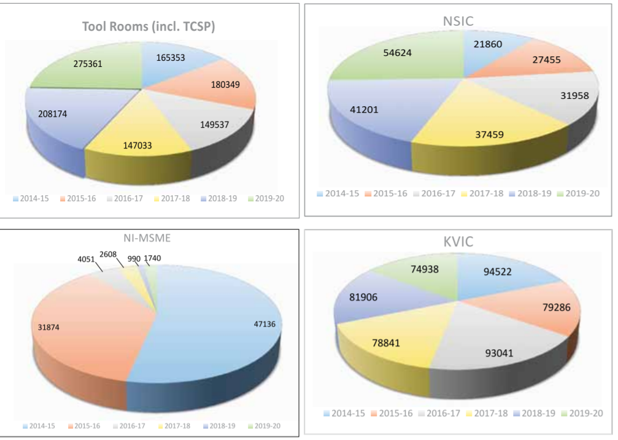

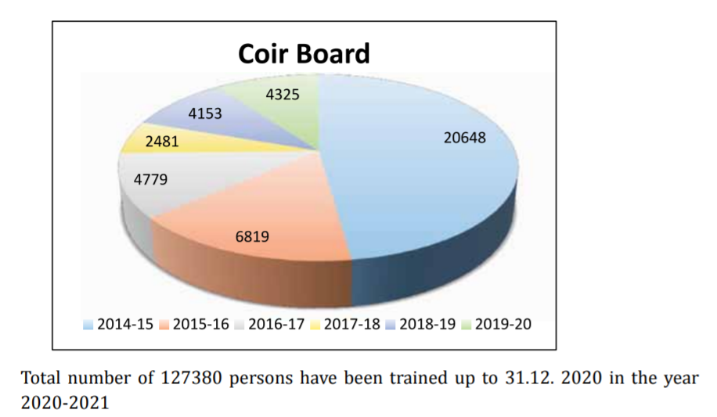

Progress of talent Development Programmes Organizations underneath the ministry are providing skill coaching to the youths for wage employment and self-employment. These training are provided under numerous schemes adore MSME-TCs, help to coaching establishments (ATI), National SC/ST Hub, capability Building, coir Vikas Yojna- talent Upgradation & Mahila Coir Yojana, and so forth Furthermore, custom demand-driven training courses as per trade necessities are conducted by organizations under the Ministry. The progress of skill development programmes conducted by the M/o MSME since 2014-15 to 2019-20.

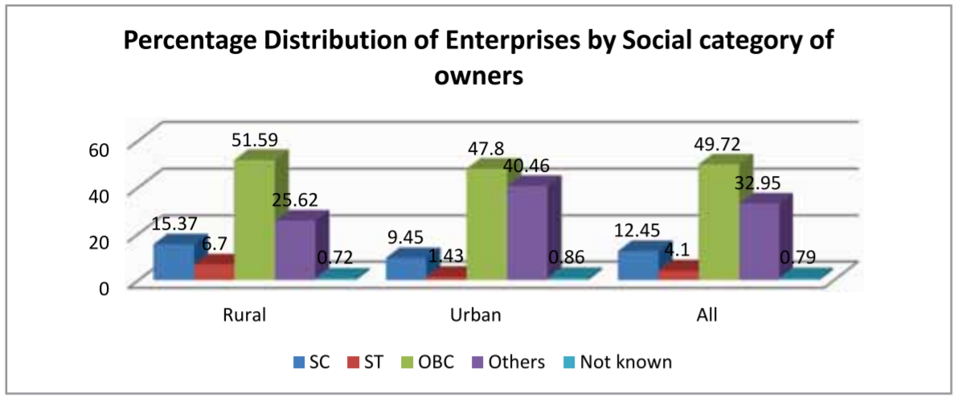

The socially backward companies owned nearly 66.27% of MSMEs. Bulk of that become owned through OBCs (49.72%). The illustration of SC and ST proprietors in MSME zone become low at 12.45% and 4.10% respectively. In rural areas, nearly 73.67% of MSMEs had been owned through socially backward companies, of which 51.59% longed to the OBCs. In city areas, nearly 58.68% longed to the socially backward companies, of which 47.80% longed to the OBCs.

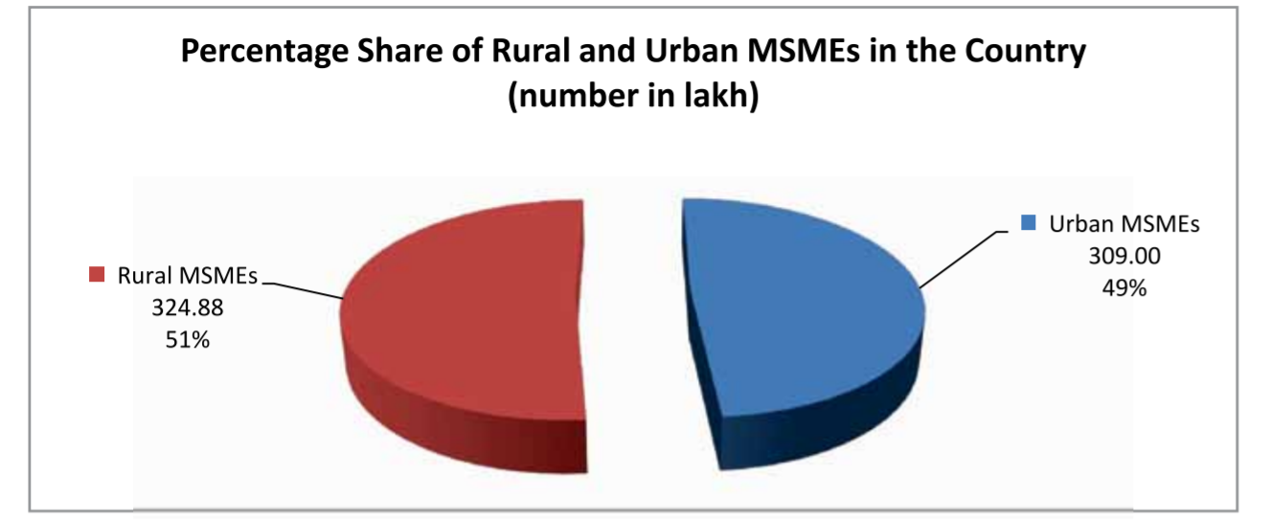the micro sector with 630.52 lakh estimated enterprises provided employment to 1076.19 lakh persons that in turn accounts for around 97% of total employment in the sector. This also further shows that the total number of employment rate is more by 10% in urban area as compared to the rural areas.

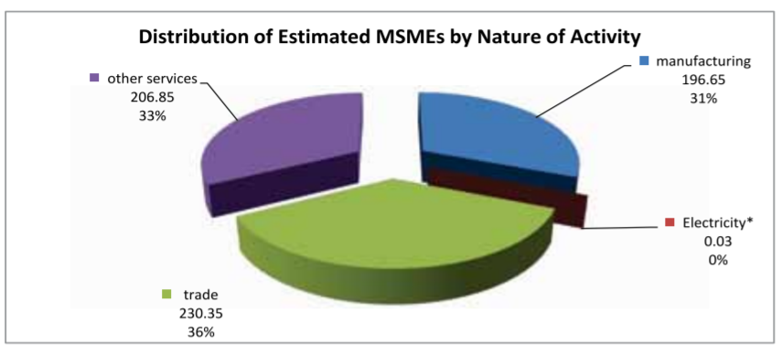

As per the National Sample Survey (NSS) 73rd round, conducted by National Sample Survey Office, Ministry of Statistics & Programme Implementation throughout the amount 2015-16, there have been 633.88 hundred thousand unorganised non-agricultural MSMEs within the country engaged in several economic activities (196.65 lakh in Manufacturing, 0.03 lakh in Non-captive Electricity Generation and Transmission1 , 230.35 lakh in Trade and 206.85 lakh in different Services) excluding those MSMEs registered below (a)Sections 2m(i) and 2m(ii) of the Factories Act, 1948, (b)Companies Act, 1956 and (c) construction activities falling under Section F of National Industrial Classification (NIC) 2008.

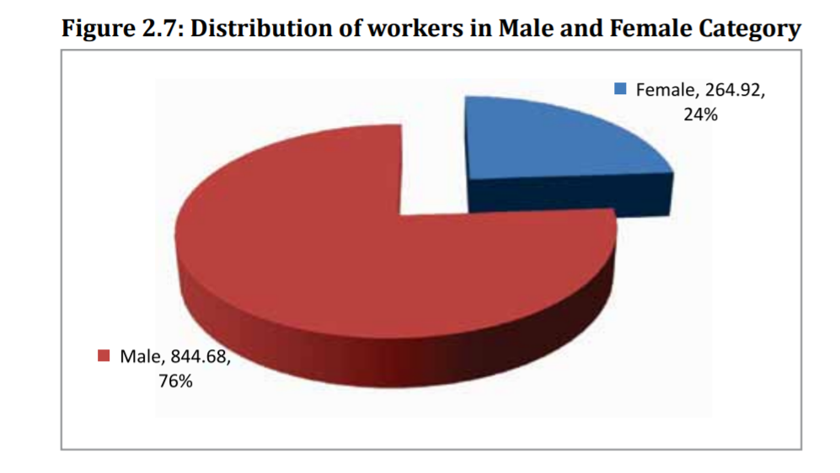

So basically, through this graph we can note that there are total 1109.89 employees in MSME out of which 844.68 are male employees and the rest 264.92 are female.

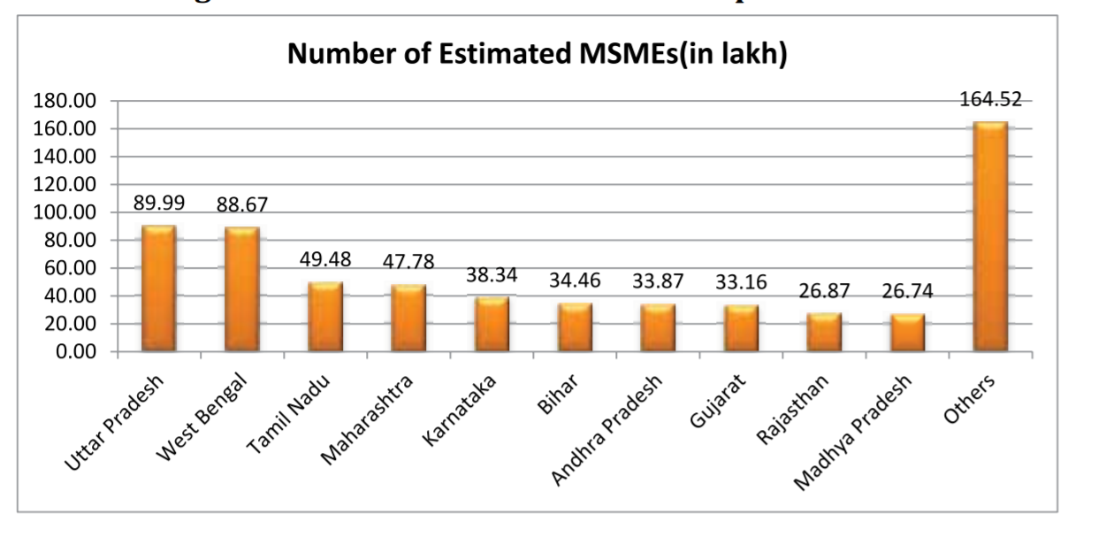

Uttar Pradesh is estimated to have the largest number of small, medium and micro enterprises, accounting for 14.20% of the country's small, medium and micro enterprises, while the top 10 states with the highest income account for 74.05% of the estimated total number of small, medium and micro enterprises in the country. Figure 2.8 shows the distribution of rated companies in the ten federal states.

# GROWTH PATTERN OF MSME

|  |  |  |  |  |  |  |  |  |  |
| --- | --- | --- | --- | --- | --- | --- | --- | --- | --- |
| **Year** | **Growth(%)** | |  | | --- | | **Total  MSME GVA** | | |  | | --- | | **Total GVA** | | **Share of MSME in GVA(%)** | |  | | --- | | **All India GDP** | | **Share of MSME in All India GDP(in %)** |
| 2014-15 | 3658196 | - | 11504279 | 31.80 | 12467959 | 29.34 |
| 2015-16 | 4059660 | 10.97 | 12574499 | 32.28 | 13771874 | 29.48 |
| 2016-17 | 4502129 | 10.90 | 13965200 | 32.24 | 15391669 | 29.25 |
| 2017-18 | 5086493 | 12.98 | 15513122 | 32.79 | 17098304 | 29.75 |
| 2018-19 | 5741765 | 12.88 | 17139962 | 33.50 | 18971237 | 30.27 |

# Market Size

* India has about 6.3 crore MSMEs. The wide variety of registered MSMEs grew 18. five% Y-O-Y to attain 25.13 lakh (2.5 million) gadgets in 2020 from 21.21 lakh (2.1 million) gadgets in 2019. The Indian MSMEs region contributes approximately 29% in the direction of the GDP via its countrywide and global trade.
* According to statistics shared through the MSME Minister withinside the Rajya Sabha, the registered MSME is ruled through micro establishments at 22.06 lakh (2.2 million) gadgets in 2020 from 18.70 lakh (1.8 million) gadgets in 2019, at the same time as small organisation gadgets went up from 2.41 lakh (0.24 million) gadgets to 2.95 lakh (0.29 million) gadgets. Midsized organizations best extended from 9,403 gadgets to 10,981 gadgets all through this period.
* MSMEs are being advocated to marketplace their merchandise at the e-trade site, specially via Government e-Marketplace (GeM), owned and run through the authorities, wherefrom Ministries and PSUs (public region undertakings) supply their procurement. The platform has recorded transactions really well worth Rs. 55,048 crore (US$ 7.5 billion) till September 2020.
* Domestic enterprise calls for a robust economic stimulus with concessional operating capital loans to make sure good enough liquidity is maintained in enterprise operations from the authorities and economic institutes.

# MSME during the pandemic and Digitalization

In India, independent companies are quickly receiving computerized methods of installments to direct business in the midst of pandemic-initiated difficulties and limitations. As indicated by a review led by Bluehost, a web facilitating arrangements supplier, Indian Micro, Small and Medium Enterprises (MSMEs) are quickly receiving computerized instalments over cash. The review further stated that, 72% of the recorded instalments were done through electronic mode i.e., from computerized mode when contrasted with 28% of money exchanges.

The overview was directed in the initial fourteen days of June 2021, which included 400 MSMEs from portions like travel, retail, instructive administrations, finance, innovation administrations, free bloggers, expert, promoting and advertising.

The beginning of the pandemic has featured the huge of utilizing innovation in organizations. The truth is that entrepreneur ventures have increased and upgraded the speed at which organizations, particularly MSMEs, are executing powerful innovation. After the pandemic hit, about 19% of the MSMEs dispatched a site in India, because of the requirement for getting new clients and brand advancement.

# RECENT DEVELOPMENTS AND INITIATIVES

* In April 2021, the non-banking finance organizations (NBFCs) mentioned the Reserve Bank of India to broaden the one-time rebuilding plan of MSME progresses till March 31, 2022, as these players can't resuscitate their organizations.
* In March 2021, the Ministry of MSME, through the Development Commissioner (DC-MSME) carried out the Technology Centre Systems Program (TCSP) to set up 15 new Technology Centres (TC). The focuses give help to the business prevalently MSMEs in General Engineering, Automotive, Fragrance and Flavour and ESDM areas.
* In March 2021, the Finance Ministry permitted private retirement assets to put up to 5% in Category I and II AIFs managed by SEBI; this will assist with broadening the raising support choices for MSMEs and grow the homegrown pool of capital
* Classification 1 AIFs comprises of framework, investment, holy messenger and social endeavour reserves. Classification II AIFs covers finances where essentially 51% of the size can be put resources into one or the other foundation, SMEs, funding or social government assistance substances
* In March 2021, MSME backing and advancement association, National Small Industries Corporation (NSIC) reported that they will help MSMEs working with the Agricultural and Processed Food Products Export Development Authority (APEDA) across various regions
* The NSIC, through a MoU with APEDA, will help its MSME individuals in investigating the fare capability of their horticultural and prepared food sources items. Furthermore, APEDA individuals will gain admittance to NSIC plans, which would help them address issues relating to innovation appropriation, abilities, item quality, and market access.
* The relationship will likewise uphold advancement of green and economical assembling innovation for MSME bunches, empowering units to change to practical and green creation cycles and items
* In February 2021, Walmart's Vriddhi program was stretched out to Uttar Pradesh, with dispatch of an e-establishment to work with private companies in allowing admittance to abilities and skills across on the web and disconnected stages like Flipkart's commercial centre and Walmart's worldwide stock chain. The organization expressed that this new e-foundation will profit 50,000 MSMEs the nation over to extend locally and internationally.
* In February 2021, MasterCard and Razor pay marked an association to help private ventures and business people in India embrace computerized instalments. The organization coordinates Razor pay’s instalment preparing abilities with MasterCard’s advanced financial stages and card administrations.
* In February 2021, Bank of Maharashtra has worked together with Vayana Network, a store network financing (SCF) stage, to give monetary help to the MSME market. Through this association, the bank will give momentary credit to address the spending needs of real corporate sellers/merchants through the bank's 'Mahabank Channel Financing Scheme' and Vayana Network's aptitude.
* In February 2021, Indian Bank marked an update of comprehension (MOU) with the Society for Innovation and Development (SID), an undertaking of the Indian Institute of Science, to give selective credit to new companies and MSMEs.
* In February 2021, the Small Industries Development Bank of India (SIDBI), a monetary organization committed to the advancement, financing, and improvement of miniature, little, and medium ventures (MSMEs), consented to an arrangement with the public authority of Andhra Pradesh to assist with growing the state's MSME biological system.

# CONCLUSION

The Indian government plans to double the Indian economy to US$5 trillion within five years; to achieve this goal, it will create employment opportunities for young people, and small, medium and micro enterprises can become an important factor in employment. The government is committed to helping small, medium and micro enterprises create new job opportunities in the industry; the government is also committed to increasing MSME's participation in exports and its contribution to GDP.

To achieve these goals, the government should invest in more server services to increase the productivity of the MSME sector in providing goods and services to large industrial companies. Lack of technology-based manufacturing activities and low RandD operational investment are bottlenecks hindering development. Globally to be had technology may be sponsored through the authorities so that you can use to be had sources to enhance the product great of small, medium and micro enterprises. It also requires scientific research institutions to provide support in the form of research and development services (RandD). For innovative products.

 BY 2030 India focuses on removing poverty, reducing inequalities, partnership for goals, zero hunger, quality education, gender equality, decent work and economy growth and development of industry, innovation and environment.

The beginning of the pandemic has featured the huge of utilizing innovation in organizations. The truth is that entrepreneur ventures have increased and upgraded the speed at which organizations, particularly MSMEs, are executing powerful innovation.

1. Student, Indore Institute of Law
2. Student, Indore Institute of Law